# CRITERION B: DESIGN

Planned GUI design and basic illustration of System Flow

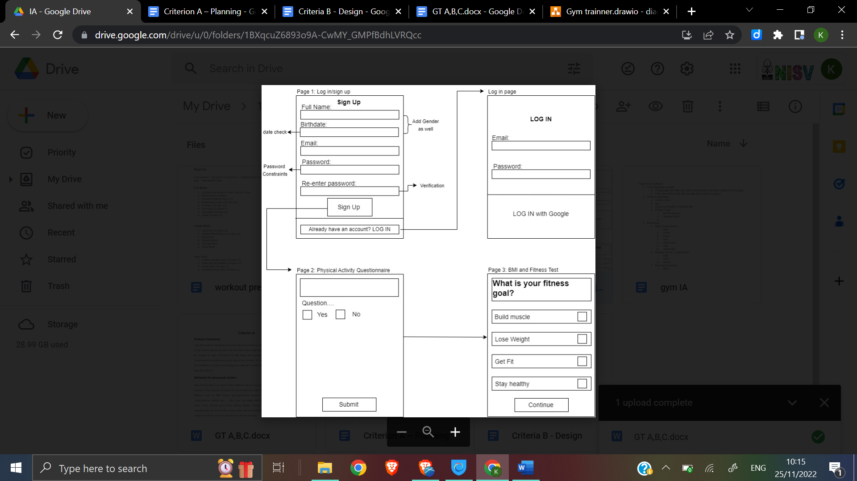

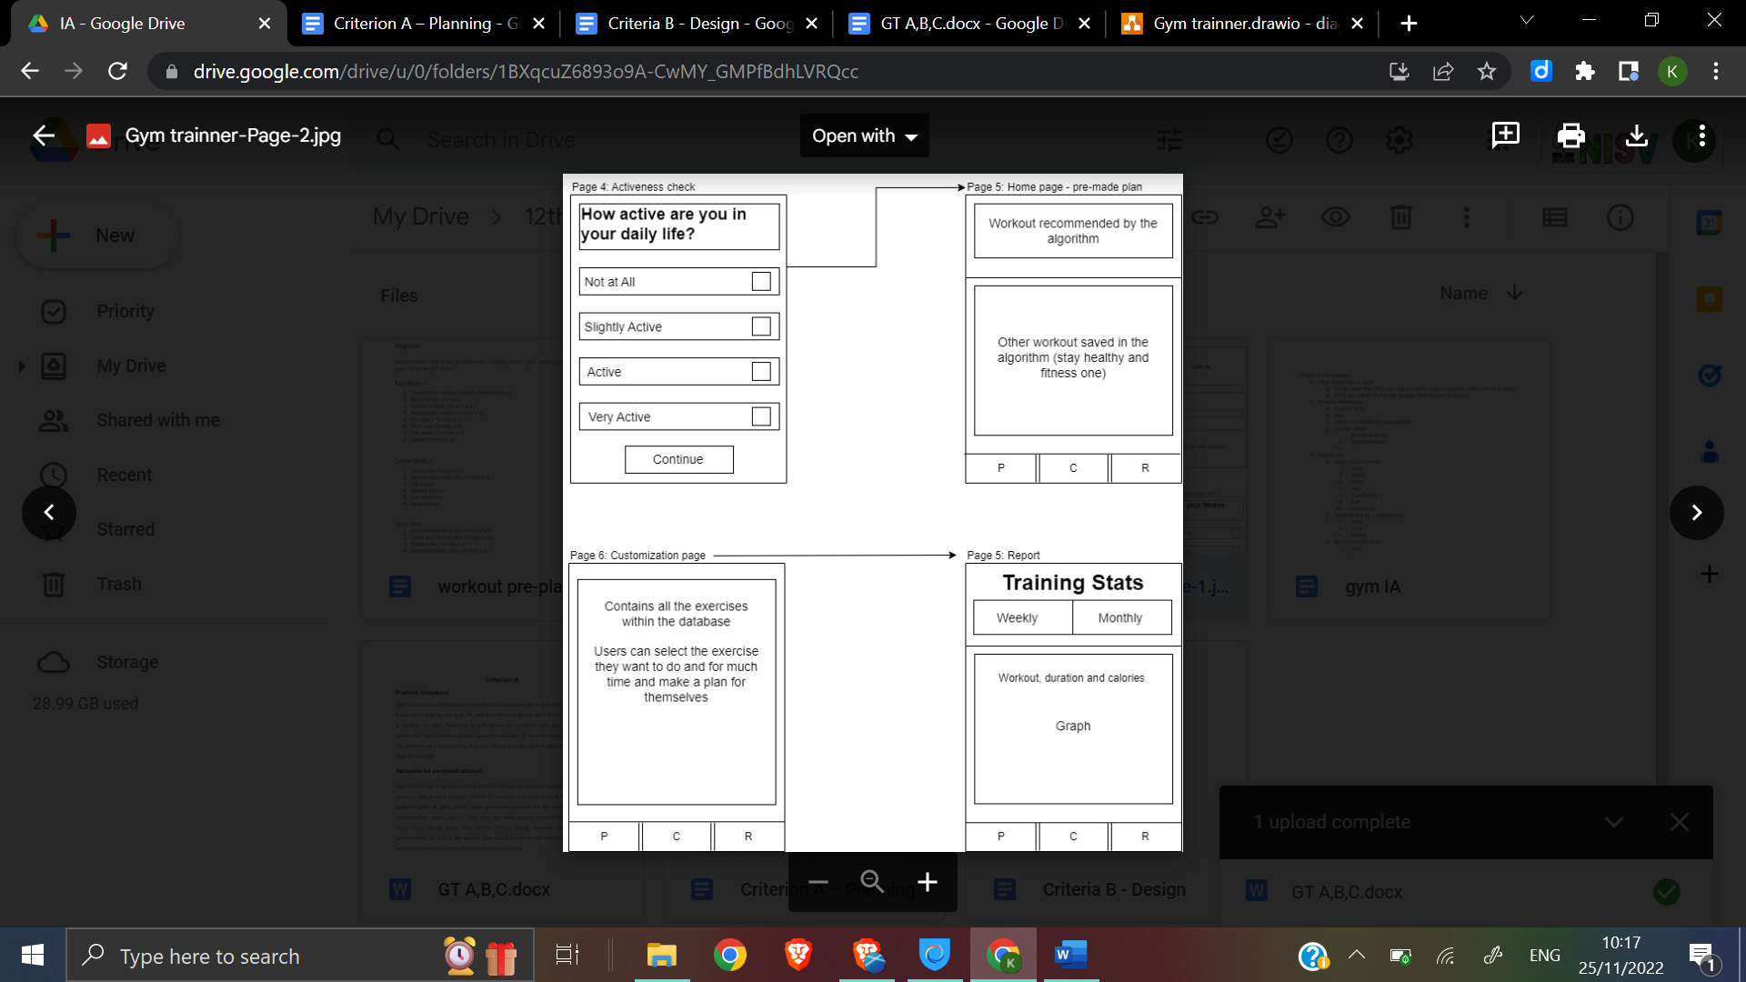

Data Flow Diagram (DFD)

1. Level 0

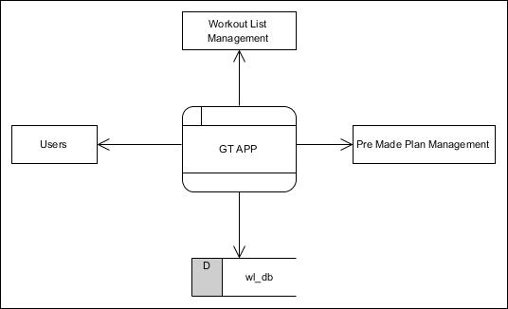

1. Level 1



1. Level 2



Database Tables for Firebase:

Table: Registration Details

| R_Details | | | | |
| --- | --- | --- | --- | --- |
| Sr. no | Field name | Type | Constraint | Size |
| 1 | u_Id | Int | Primary key |  |
| 2 | u_Name | varchar |  | 240 |
| 3 | u_Email | varchar |  | 240 |
| 4 | u_Contact_no | Int |  |  |
| 5 | u_Username | varchar |  | 240 |
| 6 | u_Password | varchar |  | 240 |

Table: BMI Details

| B_Details | | | | |
| --- | --- | --- | --- | --- |
| Sr. no | Field name | Type | Constraint | Size |
| 1 | b_Id | Int | Primary key |  |
| 2 | b_age | int |  |  |
| 3 | b_gender | varchar |  | 240 |
| 4 | b_height | double |  |  |
| 5 | b_weight | double |  |  |
| 6 | b_result | double |  |  |
| 7 | u_id | Int | Foreign key |  |

Table: Work out Details

| w_Details | | | | |
| --- | --- | --- | --- | --- |
| Sr. no | Field name | Type | Constraint | Size |
| 1 | w_Id | Int | Primary key |  |
| 2 | w_name | varchar |  | 240 |
| 3 | w_reps | Int |  |  |

Table: Custom Plan

| c_plan | | | | |
| --- | --- | --- | --- | --- |
| Sr. no | Field name | Type | Constraint | Size |
| 1 | w_Id | Int | Primary key |  |
| 2 | w_name | varchar |  | 240 |
| 3 | w_reps | Int |  |  |
| 4 | u_id | Int | Foreign key |  |

Table: Training stats

| Ts_details | | | | |
| --- | --- | --- | --- | --- |
| Sr. no | Field name | Type | Constraint | Size |
| 1 | s_Id | Int | Primary key |  |
| 2 | S_date | date |  |  |
| 3 | S_duration | time |  |  |
| 4 | u_id | Int | Foreign key |  |

UML Diagram (Use case diagram):

